UNIVERSITY OF NAIROBI

# 

SCHOOL OF COMPUTING AND INFORMATICS

ONLINE CLOTH SHOPPING STORE

OKELLO JOB OPIYO

REG NO: P15/37353/2016

SUPERVISOR

S.N Ruhiu

March 21, 2018

A project proposal submitted in partial fulfillment of the Requirements of the Bachelor of Science in Computer Science.

Contents

1

CHAPTER 1: INTRODUCTION 4

1.1 Background 4

1.1.1 Virtual Dressing Rooms Go Mainstream 4

1.1.2 How Merchants Are Adopting the Virtual Dressing Room Trend 5

1.1.3 Taking the Dressing Room Home 6

1.2 Problem Statement 7

1.3Objectives 9

1.3.1 Research objectives 9

1.3.2 System Development objectives 9

1.3 Scope 9

1.4 Justification 10

Chapter 2: Literature review 11

2.1 Introduction 11

2.2 Overview of online shopping stores 11

2.3 Virtual dressing rooms 11

2.3.2Why is this technology so important for customers? 12

2.4 Preview of existing stores 13

2.4.1 Mimi Kenya 13

2.4.2 Jumia Online Stores Kenya 14

2.4.4 Mama Mike’s Online store. 14

2.4.4 Sensemi online 14

Chapter 3: Methodology 15

3.1 System Development Methodology 15

3.2 RESEARCH METHODOLOGY 17

3.2.1 Research Design 17

3.2.2 Target population and Sampling frame 17

3.2.3 Data collection methods and instruments 17

3.2.4 Data analysis 17

3.3 SYSTEM DEVELOPMENT METHODOLOGY 19

3.3.1 Requirement Specifications 19

3.3.2 System analysis and design 20

3.3.3 System coding 20

3.2.4 System testing and debugging 20

3.3.5 System deployment and Maintenance 21

3.2.6 Resources required. 21

4. System design 22

4.1 Use case diagram 22

4.2 Context diagram 25

4.3 Level 0 Data Flow Diagram: All system processes 26

4.4 Level 1 Data Flow Diagram: Payments 28

Chapter 5: Project plan and management 29

5.1 Project activity plan 29

5.2 Project Gantt Chart 30

5.3 Required Resources 30

5.3.1 Software resources 30

5.3.2 Hardware resources 30

References 32

# CHAPTER 1: INTRODUCTION

## 1.1 Background

Clothing is one of the basic human needs that we require in our daily lives. From time immemorial people have always had to find different ways of clothing themselves and ensuring that they not only look appealing but also feel. The way an individual dress up says so much about them. Clothing has gone beyond its initial purpose of simply covering and offering protection to being a symbol of social status. This therefore means that as much as possible individual will try anything in their ability to ensure that they get the best clothes available in the market and as soon as they are available.

In the past inn order to acquire clothing on e had to make the tiresome to and from the market to get their hands-on clothing. This has been and still is one of the methods that ensure one can be able to ensure that they dressed up ready for the next day’s event or simply activity. In order to ensure that most they always get the out of life many individuals therefore end up having to work up to multiple shifts a day or even be in occupations that takes most of their time leaving shopping to look like a luxurious activity due to time constraint.

Thanks to advent of technology one does not have to necessarily visit his/her local market or shop just buy a new apparel that they may desire. This is because an individual can easily carry out the same activity from the comfort of their homes. Many stores are therefore following the trend of moving their services online in order to reach a wider area of customers.

### ****1.1.1 Virtual Dressing Rooms Go Mainstream****

Need new glasses? Upload a selfie and match frames to your face online instead of shlepping to a store. Just moved across town? Check out how couches will fit into your new space without ever leaving your living room.

This new way of shopping — using a virtual dressing room experience as opposed to the traditional brick and mortar equivalent — has gone from exceptional to commonplace as the trend becomes more popular with retailers and consumers alike. According to[PwC’s 2018 Global Consumer Insights Survey](https://www.pwc.com/gx/en/industries/consumer-markets/consumer-insights-survey.html), 60 percent of global citizens surveyed have experienced virtual reality while shopping.

Today more than ever before, individuals are asking for what they really want, and refusing to accept mediocrity in all aspects of life. You’ve heard about the plight of the millennial who wants to save the world, work flexible hours in a cool environment, and make six figures while doing it? Depending on your personal take, you might find that refreshing or frustrating. Either way, that same millennial wants to try on her lipstick before she pulls out her card, and retailers are hearing her loud and clear.

### ****1.1.2 How Merchants Are Adopting the Virtual Dressing Room Trend****

The advantages of a virtual dressing room extend to both retailers and their customers, and there’s lots of room to get creative.

With its Virtual Artist app, makeup giant Sephora lets customers try on products to their hearts’ content. Users can upload close-up facial shots so that they can virtually apply anything to their unique features, from eye shadow to bronzers and blush. The app ensures customers are sure and satisfied with their decision to drop $40 on concealer.

Making further use of these close-ups, the app allows shoppers to interact with the platform by watching tutorials on how to apply makeup products they might not know how to use. In this way, the beauty brand exposes customers to products they may have otherwise overlooked.

Other cosmetic companies, like Smashbox and Covergirl, have also invested in artificial reality platforms to enhance purchaser engagement. The goal is to get would-be-buyers across the finish line.

Traditional clothing retailers are following suit (no pun intended). If you’ve ever squeezed yourself into a traditional dressing room, you know they can be uncomfortable and time consuming. Whether you’re a big city shopper who tires of long lines or a rural fashionista who has to drive 30 minutes to the nearest mall, fitting rooms usually aren’t the highlight of your day. That’s why bridging the gap between a need to see how things fit and an aversion to seeing yourself bare in gas station-like lighting is starting to take off.

Gap has entered the virtual fitting room scene with an app called Dressing Room for trying on clothes before making a purchase. Users can access the app with any Google-Tango device. Customers have the ability to move their self-made avatar around so they can check themselves out from all angles in their new outfit.

Gap isn’t alone in the clothing space — several sites exist just to serve as virtual 3D fitting rooms. In these online “rooms”, window shoppers can enter their height and weight (as well as hair and eye color if the AI allows) to see how clothing will fit their exact body type.

It all comes down to customer experience — buyers want to be in control when it comes to spending their hard earned dollars.

### ****1.1.3 Taking the Dressing Room Home****

Marketers have the task of making shopping experiences more seamless, and they have become experts at creating environments that make it as easy as possible to buy.

Virtual dressing rooms are a revolutionary first step. Adding the option for deferred payments takes the experience even further. Sure, virtual dressing rooms help shoppers visualize what they’re buying, but the experience still lacks that physical, visceral touch.

With the rise of payment solutions like Klarna’s [Pay Later,](https://www.klarna.com/us/business/products/pay-later/) e-commerce merchants can offer shoppers more [payment options](https://www.klarna.com/knowledge/article/shoppers-demanding-payment-options/), including the ability to pay *after*they make a purchase. With Pay Later, shoppers can have their order delivered, test it out, and then pay for what they want to keep. That pair of jeans that looked so good in the virtual fitting room  aren’t so flattering in the stark light of reality? Send them back! You don’t need that kind of negativity.

In an e-comm environment driven by innovation and infinite options, customers are finally king (and queen) and it’s okay to act like it. Virtual dressing rooms paired with the ability to [try before you buy](https://www.klarna.com/knowledge/article/try-before-you-buy-online-shopping/) are the latest way for retailers to bring the ultimate in customer experiences.

## 1.2 Problem Statement

Clothing is one of the basic human needs, and since time immemorial buying cloths has always been an activity that was confined within markets and shopping stores. This therefore meant that to acquire a cloth one had to leave home head to the market for the purpose if shopping. the modern individual however is a person who would handle more than one job just to keep up with the harsh economic times. As a result, such individuals are deprived of time to carry out shopping. despite all of this technology has however enabled such individuals to carry out shopping from the comfort of their homes. This is enabled by stores that took on online shopping as a business model.

This however did not solve most of the problems that exist in the current market. This is due to the fact that the most of the current online shopping stores lack variety and customization. This can be owed to the fact that the stores have a fixed set of designers that supply them with their clothing merchandise. As a result, most of the local designers who are equally and even more talented are left to only sell their merchandise to a limited network of shoppers i.e. those within their locality.

To solve this issue a platform should therefore be created to allow the local designers to sign up and get an opportunity to widen the customer network and earn a living. This platform should also take advantage of the individuals within the transport sector who will also get an income earning opportunity by being able to offer their shipping services at a fee. At the end of it all we will have a satisfied customer due to having more options to choose from and designers and transporters who get to earn a living for the services that they offer.

Despite having come up as a sigh of relief for most shoppers online shopping has left out lot of areas that are yet to be addressed. These areas affect both the shoppers and the designers alike due to their nature of importance. Beginning with the shoppers as much as there is very little attention paid to the actual fitting of the cloths bought by the shopper. Most of the local shops have very little effort put into ensuring that the customer gets the cloth that fits them. Since comfort majorly influences the decision on whether or not to buy a given piece of cloth from an online store. This also contributes to a lot of purchase return which are both tiresome activities to the both the store and the shoppers.

Another issue of concern falls on the online stores and the list of designers who they choose as their clothing suppliers. Most of the local stores usually have a limited number of designers whom they have chosen as their suppliers. This therefore leaves a huge number of talented designers with the option of selling their wares only within their areas of locality. This in return denies them the opportunity to gain more market exposure and relevance hence contributing to very low sales to a limited range of consumers.

The above-mentioned problem also ripples back to the shopper. Due to a limited number of designers on the platforms the shoppers are also forced to deal with a limited variety of clothes available on the online shops. This in a way will force the shoppers to go back to the physical shopping to ensure to ensure that they get what they really desire. A system that tackles this problem is therefore required to ensure that at the both the shoppers and the designers are satisfied at the end of the day.

## 1.3Objectives

### 1.3.1 Research objectives

1. To establish an understanding on how online shops work.
2. To understand the process of cloth designing techniques
3. To understand technologies that are in place to ensure that the shopping process is optimized in online stores.

### 1.3.2 System Development objectives

1. Creating a system that will enable users to login as either shoppers and designers
2. A system that will enable shoppers to connect to designers within a similar geographical so as to save on time and cost of services between both parties.
3. Creating a system that enables shoppers to evaluate the products and designers prior to paying for the services.
4. Coming up with a system that will enable shoppers to body measures before they make a purchase to increase successful purchases.
5. Designers should be notified once they have booked for the design of a shoppers clothing.

## 1.3 Scope

This project will cover the development of a web-based application that will be aimed at achieving the following goals:

1. Give shoppers ability the ability to buy cloths from the online store regardless of their geographical positioning
2. Enable shoppers to be able to make orders on while confirming the accuracy of their body measurement.
3. Ensure that designers are able to receive and process orders from the shoppers through the store.
4. Ensure that the designers are able to reach a wider customer based all over the country.

## 1.4 Justification

With the current technological advancement and explosion of the internet globally, Kenya is of the countries that is enjoying the benefits of such advancements with above 60% of its population having access to the internet and other technologies that seem to make the world a global village. This therefore means that at least 6 out of every 10 Kenyans have access to the internet services. This is further boosted with the mobile phone penetration with over 80% of the population having access to mobile phones and other computing devices. Having this knowledge in mind we can therefore observer that a web-based shopping would be a perfect fit as a technology to deploy our online store. This is due to the fact that website can be accessed across all devices and across all technologies used to deploy mobile services. This there means that whether an individual is on IOS, Android, Linux and Windows device or using a smartphone, tablet, desktop or laptop computer, the individual will still be able to gain access to the shopping services.

# Chapter 2: Literature review

## 2.1 Introduction

This chapter aims at taking a look at the current online shopping that mainly focus on clothing as their main product. The problem statement highlighted in chapter on will be looked into in more detail with respect the existing stores selling cloths using the various online platforms available. The chapter will consider the factors affecting customers as they make their purchases from these stores. The various issues facing the online stores will be analyzed and be used to point out the various issues the online stores. The knowledge acquired from this chapter will then be used to form the basis of strength and uniqueness for the online stores that is to be developed in this project. This will also enable the business to have better operational model that will ensure a higher return on investment and within a short period of time.

## 2.2 Overview of online shopping stores

In today’s world the average adult is most an employee who spends a better part of his day at the work premises. This therefore leaves such an individual with very little time to carry out other personal activities such as shopping. Thanks to the evolution of technology and the rise of the internet, this individual is now able to carry out shopping for most of the daily items that they might need in their household from the comfort of their homes. This comes even more handy in the busy holiday season where the individual only is saved from the trouble of waiting in long queues and having to bother with the opening and closing of the stores since online stores are open 24 hours a day. Another interesting thing about online clothing stores is that the customer is able to find a huge variety of items from the same store, somethings that would have require them to move from shop to shop if they were shopping manually. In the next sub section, we will a look at the virtual dressing rooms as well as the existing online stores in the country such Mimi Kenya, Jumia Kenya and Mama Mike’s Online store.

2.3 Virtual dressing rooms

Virtual changing rooms have technically been available for a while but so far, they have not been generally adopted by retailers. If we are to believe all the hype virtual changing rooms are the silver bullet for fashion retailers and totally revolutionize how we shop for clothes both online and instore. So why the hype?  
  
2.3.1 Virtual changing rooms will reduce costs for fashion retailers  
  
The changing rooms are an area of stock loss and are always a high staffing cost, while online customer return 25 percent of purchased clothing with 70 percent being for the wrong size.

2.3.2Why is this technology so important for customers?  
  
Just imagine you are about to go out to a special event and cannot find the right outfit. Today it’s a real challenge, but tomorrow you go to your favorite retailer’s website try on a number of outfits via their virtual changing room. They will already have your size programmed and you order. Two hours later, yes two hours later, it’s at your home and you are having the outfit you need. This will be fashion retail of tomorrow.

2.3.3 The virtual dressing room technology  
Virtual fitting rooms normally create a mannequin so shoppers can see how different sizes may fit their shape, by customers simply entering some basic measurements and a virtual mannequin adjusts to fit their dimensions. The customer then can then dress the mannequin with different sizes, allowing them to see how different garments will fit before making their purchase. There are different technical solutions which is making it far more challenging for retailers to pick one. These methods include:

1. **Body scanners** – This technology comes in two distinct flavors: scanners that use technologies such as webcams, phone cameras, or Microsoft’s [Kinect](http://en.wikipedia.org/wiki/Kinect) device and scanners that uses some more sophisticated technologies requiring the shopper to travel to the scanner. Web and phone camera technologies require users to stand a fixed distance away from the camera and to hold a standard-sized object (such as a CD) that the camera can use as a reference for size. The more sophisticated scanners that use [laser](http://en.wikipedia.org/wiki/Laser) or [millimeter wave detector technology](http://en.wikipedia.org/wiki/Extremely_high_frequency), or even multiple arrays of Kinect sensors, are too bulky and expensive to be used in most stores and are located instead in shopping malls or in large department stores. Customers are required to visit the location to be scanned and this information may then be used on online sites.
2. **3D fitting rooms** – These use computer-generated 3D images to create an experience similar to that seen in [virtual world](http://en.wikipedia.org/wiki/Virtual_world) computer games. These solutions generate a virtual mannequin (avatar) using customer body measurements and shape information. An avatar of the shopper is created, this requires the shopper to measure himself or herself and provide these data. Sometimes the avatar may be personalized: racially, or by skin tone, or by application of pre-determined hairstyles, or even by uploading an image of a customer’s own face. The avatar may then be used to show how the shopper would look wearing the clothing, accessories and any other items on sale. Versions that are more sophisticated allow side-by-side comparison of different versions of a garment, and enable different items to be tried on at the same time.
3. **Fitting room with real 3D simulation** - Real 3D Simulation fitting room combines the features of 3D solutions and photo-accurate fitting rooms. Using a combination of photo and simple body measurements, the solution generates a 3D mannequin, which accurately visualizes customer in chosen apparel items. Normally, the system suggests an appropriate size for entered measurements, but customer can also choose other sizes to estimate their fit.
4. **Augmented reality** – Most Augmented Reality Virtual Dressing Room solutions work by superimposing the 3D model or picture of a garment or accessory within the live video feed of the customer. The superimposed 3D model or picture of the garment or accessory will then track to movements of the customer so it appears as if the customer is wearing the virtual item in the video view. Augmented Reality Virtual Dressing Rooms usually require a desktop webcam, a smartphone camera or a 3D camera, such as Kinect, to function. An example of Augmented Reality utilized for Virtual Dressing Rooms includes use of a 3D camera to manipulate areas of a garment or accessory within a display.
5. **Photo-accurate virtual fitting rooms** - This technology is a convergence of two techniques: using real models and dress-up mannequins. Instead of photographing garments on people similar to customer’s shape and size, images are made using shape-shifting, robotic mannequins. The computer-controlled mannequins quickly morph through a series of body shapes and sizes while garments in each different size are photographed and the image stored in a database together with the measurements that generate the image. Since the mannequins are computer-controlled, the whole process is relatively fast. In the final version, the mannequin is edited out from the photography and replaced with a virtual avatar, which can be changed to reflect the brand involved. Once a customer inputs their measurements into the systems, the image in which the mannequin has the same measurements as the shopper is retrieved from the database and shown to the customer. (Register, 2018)

Technology is advancing fast and delivering many different options, so it’s clear that technology-based companies believe virtual dressing rooms are worth the investment. Which technology is best is still open to debate, but the best technology does not always determine the winner? It’s a combination of financial investment, marketing, and most importantly - user experience.  
   
The failure to adopt this technology will only be acceptable for the discounters and value retailers. The big question for fashion retailers is which one to choose and for this, all fashion retailers would do well to take independent advice.

## 

### 2.3.4 virtual dressing room cheaper alternatives

Despite virtual dressing room being a revolutionary way of handling online apparel shopping, the technology is still basically an expensive venture for a large population of the retailers and shoppers alike. This is due to the fact that the developers will have to deal with the hustle of affording very expensive equipment. As a result, the retailers will therefore be forced to increase the prices to the apparel so as to be able to carter for the cost incurred in the retail process. Shoppers under the pressure will also be forced to take on the only close and viable option which will be going back. To the traditional form of apparel shopping. this constraint can however be overcome if a cheaper alternative will to this technology is used. To achieve this, I will therefore use the readily available webcam that comes with a majority of the modern laptops and desktop computers alike. This will work by taking the image of the individual alongside a common object which will be in the background. The body measurements of the individual will therefore be calculated in relation to the reference object in the image.

For most parts of the measurements the linear formulas will be used to achieve the results. For the waist however a special mathematical formula known as the Ramanujan algorithm will be used to calculate the results. This formula will assume the elliptical shape of the human waste as illustrated in the image below:

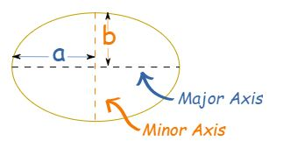

The formula is as follows:

1. We first find the value of “h”

h = (a-b)^2/(a+b)^2

2: using this we will then be able to calculate the perimeter.

ellipse perimeter approx pi(a+b)(1 + 3h/(10+sqrt(4-3h)))

## 2.4 Preview of existing stores

### 2.4.1 Mimi Kenya

Mimi online store’s offices are located in Nakumatt road, Kahawa Nairobi and First floor, Avenue House. Mimi influences the fashion Kenyan ladies take especially the middle class where the targeted average dresses is about 3000.Delivery is done well as long as you wait their delivery days. Presenter Julie Gichuru centered her business plan around the growing culture of online trade and commerce that is already fast developing where online offers increased accessibility to markets than a shop in a mall. It also has classy, sophisticated and trendy fashion for everyone especially Kenyan ladies. It is also one of the Kenyans leading selling of clothes through her dressing attracts and her general popularity. This effectively makes her store get return on investment within a short period of time where she gets ten compliments and dressing suggestions on her social media after every Sunday live. It’s getting down comes where Mimi starts settling on high cost of rental properties in Kenya means an online that customers would have to pay much more for venture for their merchandise and this may make ladies who are below middle not to shop there. Also, when one is delivered a dress, she may find it is not of her size. (Anon., 2018)

### 2.4.2 Jumia Online Stores Kenya

Jumia offline stores are in Nairobi CBD Emperor Plaza, Kenyatta Avn. Opp. GPO. It is an open business-to-consumer platform enabling business to reach Africa’s vast and growing consumer market. It has established itself as the destination for quality, branded products, catering and to an increasingly sophisticated African consumer(s). Their growth is largely influenced by the professionalism and carrier growth of their employees which they have backed with test practices and effective knowledge transfer from across the globe. It also provides opportunities for staff to grow across different roles in the organizations. Their employees have access to a comprehensive health plan which includes, their spouse and children and competitive salary package. When shipping in Jumia shopping store, making payment means accepting delivery. Therefore, it is not possible to open products bearing manufacturers seal, reject and send them back with the same driver if the product is oversize or smaller .it can only be returned if you haven’t opened and allow the return policy. For the ones overseas or anyone who wants to return, one will incur an extra shipping fee of ksh.100 when returning. (Anon., 2018)

### 2.4.4 Mama Mike’s Online store.

Mama Mike is also another one of the upcoming online stores. It deals mostly with adult clothing hence narrowing down their target market to mostly adults between the ages of 30-50years. This is due to the fact they focus mostly focus in the urban ware franchise, which has managed to attracted the customers within that given age bracket. Just like Jumia and Mimi, the store has a lot of similarities when it comes to identifying a dress is and get it is a simple as just logging into the site and picking your dress and waiting for the delivery. (Anon., 2018)

### 2.4.4 Sensemi online

This is a Dubai based that also deals in online clothe purchase. Different from the above-mentioned Kenyan stores sensemi has been able to introduce the concept of virtualized dressing rooms into their stores. Their stores have fitting rooms that contain digitalized fitting rooms with screens solely dedicated to only enable customers to get a feel of what would feel like once they will they have bought the cloth. This has enabled them to reduce the numbers of purchase returns as well as helped improve the shopper’s decision-making process before a purchase is made. This however only constrains the shoppers to always have to visit the shop in order to be able to try out the clothing virtually. (Anon., 2019)

# Chapter 3: Methodology

## 3.1 System Development Methodology

This project will make use of the rapid development methodology. This methodology primarily focuses on the following activities

1. Requirement analysis – this phase focus mostly on the data modelling for the system to be created. The output in the data modelling will be very essential in determining which the overall build of the system. Data objects are defined to model the information flows identified in this phase. This phase will enable the determination of characteristics and relationships amongst data objects.
2. Design – once the requirement modelling is done the design process will then enable the business processing model in which the data models will be used to come up with a well-defined information flow of the system.
3. Prototyping – this phase will the focus the attention on building up the most critical components of the system in a repetitive and incremental manner. The process will enable the identification of any constraints of the system in the early stages of development hence give room for the correction while getting user feedback.
4. Testing – once the prototype is complete the final system will they be built from the prototype and then be deployed to the various users for the purpose of testing.
5. Implementation – once the user has tested the system and verified that all functionalities are good to go, the system will then be finally launched for use.

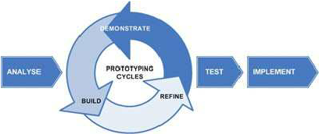

Why use RAD?

* Changing requirements can be accommodated.
* Progress can be measured.
* Iteration time can be short with use of powerful RAD tools.
* Productivity with fewer people in a short time.
* Reduced development time.
* Increases reusability of components.
* Quick initial reviews occur.
* Encourages customer feedback.
* Integration from very beginning solves a lot of integration issues.

## 3.2 RESEARCH METHODOLOGY

This is the manner in which a problem to be solved through the creation of a new system will be identified and given a logical sequence of steps that will contribute towards the solving of the problem at hand. In our case the internet will serve a great purpose in identifying the existent systems and their shortcomings which will play also enable the creation of an enhanced system. In the instances where further clarity is needed the owners of the existing systems will be contacted for more information.

### 3.2.1 Research Design

This is the general nature of the method used to carry out research for the development of a new system. In this case the knowledge of existing systems will be quite essential in mapping out the how the new system will be built so as to make the system more efficient than the existing ones.

In this case, questionnaire was the main method that was used in the collection of data. The questionnaire was designed based on the knowledge of existing systems that are currently carrying out online retail of cloths to shoppers. The questionnaire was distributed to the respondents with an aim of identifying the functioning of the existing systems, the weaknesses and also the profiling of the shoppers themselves.

### 3.2.2 Target population and Sampling frame

The questionnaires were distributed to 64 respondents within different locations including the campus. The respondents were chosen based on their availability and their willingness to answer the questions given to them. This exercise was in accordance with the quantitative data collection procedure. Most of the respondents were also chosen based on their age in that there all had legal consent to carry out purchase shopping from stores that offered online retail services. This therefore meant that their ages were ranging from the ages of 18 years to 70 years of age.

### 3.2.3 Data collection methods and instruments

The most suitable method of data collection in the research were the use of questionnaires. Through the questionnaire a survey of the target population on their interaction with online shopping services was carried out. The questionnaire was divided into two parts. The first part was focused upon the users themselves. This helped in collecting demographic information such as age and gender of the respondents for the purpose of population profiling. The second part of the questionnaire was focused on the existing similar systems carrying out online retail services. The questions on this part of the questionnaire mainly focused on the respondent’s experience while shopping online for clothes. This also gave data that enabled the looking into the system and be able to spot the areas of weakness in the systems and come up with a better system. From the data collected from the questionnaire the following analysis was able to be carried out and enabled to me to gain insight on both the

### 3.2.4 Data analysis

After the data collection was done through the questionnaire was done, an analysis was carried and the following results were obtained according to the questions asked in the questionnaire. This analysis was carried out using the descriptive statistical analysis for the preparation of the averages using graphs and frequencies.

1. **Demographic analysis**

According to the demographic collected from the respondents using the questionnaires it was found that 55% of the respondents were male while 45% of the recipients were female.

The majority of the respondents making up 64% were also found to be in the age bracket of 21 – 25 years of age.

This also went in hand in hand with the fact that the 58% of the respondents were college students. The respondents were also found to be reluctant in shopping online as 50% of them shopped online while the remaining portion preferred to shop online for goods at least once in a month.

Despite all that a majority of the respondents still gave the online shops a preference over the normal physical shopping.

1. **Existing system analysis**

When it came to the experience with the existing system the respondents still gave online shops a preference to the traditional shopping methods. The respondents also placed the quality of clothing as the main reason as to why they would opt to buy clothes from online stores as shown by 45% of their responses.

Though the respondents still liked shopping for clothes online they still preferred to pay for the purchase cloth items upon delivery as opposed paying online before the product is delivered as shown by 87% of their responses.

The respondents also wanted their purchased items to be delivered at their homes instead of the agreed pick stations set up by the stores as seen in 64% of the responses.

Smartphones and laptops were also found to be the main prefers device for carrying out shopping due to portability and the ability to access online store applications and websites as shown through 66% of the responses.

When it came to spending most of the respondents were found to have spent between ksh. 1000 – 5000 while shopping online for clothes as shown by 71% of their responses.

These respondents also stated that their shopping while online was not out of the spur of the moment as is commonly believed but planned as shown by 71% of their responses.

Despite having so much confidence in online stores 43% of the respondents would still try and makes comparison of their purchase with local offline clothing stores.

When it came to taste and customizations the respondents 71% of the respondents still preferred to have customized clothing before purchasing them.

## 3.3 SYSTEM DEVELOPMENT METHODOLOGY

The system will be developed using the Waterfall Project Management model. The model will contain the following steps:

1. Requirement specifications
2. System analysis and design
3. System Implementation/coding
4. Testing and Debugging
5. Deployment and Maintenance

### 3.3.1 Requirement Specifications

**Functional requirements**

The system should be able to meet the following functional requirements:

1. The system should enable users to create accounts and be able to carry out their roles i.e. shoppers, Designers and transporters.
2. Designers should have the ability to also create their own account s and be able to display their merchandise.
3. The system should have a mechanism of communication between the shoppers and the designers.
4. The system should enable the shoppers to make payments for their service and also enable the payment of the designers and the transport facilitators upon the completion of each purchase.
5. The system should enable the client to view the list of available designers and their products.
6. The system should enable the shoppers to be able to keep track of their purchases while designers keep track of their sales.
7. The system should also have a mechanism of enhancing the navigational capabilities of the transport facilitators during the delivery of the purchased goods.

**Non-Functional Requirements**

The system should be able to meet the following non-functional requirements:

1. **Usability –** the system should have a user-friendly interface for ease of use.
2. **Security –** the system should be able to guarantee the safety of user data and security of each transaction.
3. **Reliability –** the system should be accessed all 24/7 with less technical requirements
4. **Flexibility –** the system should be accessible from any device regardless of the operating system and hardware architecture.
5. **Accuracy –** the system should be accurate in terms of data inputs and outputs for all users.

### 3.3.2 System analysis and design

The system will be broken down into two parts:

1. **The front end** – this will be the website which the users will be interacting with. It will be composed of several webpages based on the user’s activity in the system.
2. **The back end** – this will be the part of the system that will be made up of the system’s database and be responsible for carrying out data processing.

The design of the system in terms of data flow will be represented using data flow diagrams and entity relationship diagrams.

### 3.3.3 System coding

The implementation and coding of the system will be done using the following software:

1. WAMP Server – a software that enables the local hosting of the website during the development period.
2. Sublime Text – this is an advanced text editor with support for languages such a HTML, CSS, JavaScript, PHP, MySQL and many more.
3. Google Chrome browser – this will be the testing browser for the system.
4. Windows 10 operating system – the operating system upon which the system will be deployed and tested during development phase.

The following scripting languages will be used:

1. **HTML** and **CSS** – language for the front-end design of the system’s webpages
2. **JavaScript** – language for enhancing interactivity and data entry validation on the webpages.
3. **PHP** – the language for connecting the webpages to the database of the system.
4. **MySQL** – the language implementing the system’s database.

### 3.2.4 System testing and debugging

After completing the development of the system testing will be done in order to ensure that the system functions as expected. The testing will be done in the following terms:

1. **Unit testing** – This will involve testing each module in the system for any error during performance.
2. **Integration testing** – this will involve the testing of how different in the system work when combined to work on a given task in the system.
3. **Data validation and exception testing** – this will be done by entering both correct and incorrect data input into the system so as to see how the different modules will process data even in exceptional situations.
4. **System testing** – when all the above stages of testing are completed the whole of the system will be tested before being deployed.

### 3.3.5 System deployment and Maintenance

After completion of the testing and debugging phase of the system development life cycle, the system will then be deployed to a few users for testing for a given period of time so as to get the overall response on the system from users. The feedback from the users will then be used to tweak the system further in order to fit the overall user liking.

### 3.2.6 Resources required.

The hardware resources required for the development of the system will include:

a. Desktop computer or laptop having 4 GB of RAM, 300 GB of storage space 1 GB graphics memory.

The software resources required for the development of the system will include:

1. Windows 10 operating system
2. Sublime Text 3 text editor
3. Google Chrome Browser
4. WAMP server software

# System design

# 4.1 use case diagram

Use case models give high level description of system by outlining the interaction between the users of the system and the system itself. This enables the modelling of the systems functionalities to the system requirements collected during the requirements stage of the system development life cycle. Use case diagrams use cases which are the various functionalities of the system and the actors who are the entities that interact with the various uses cases found in the system

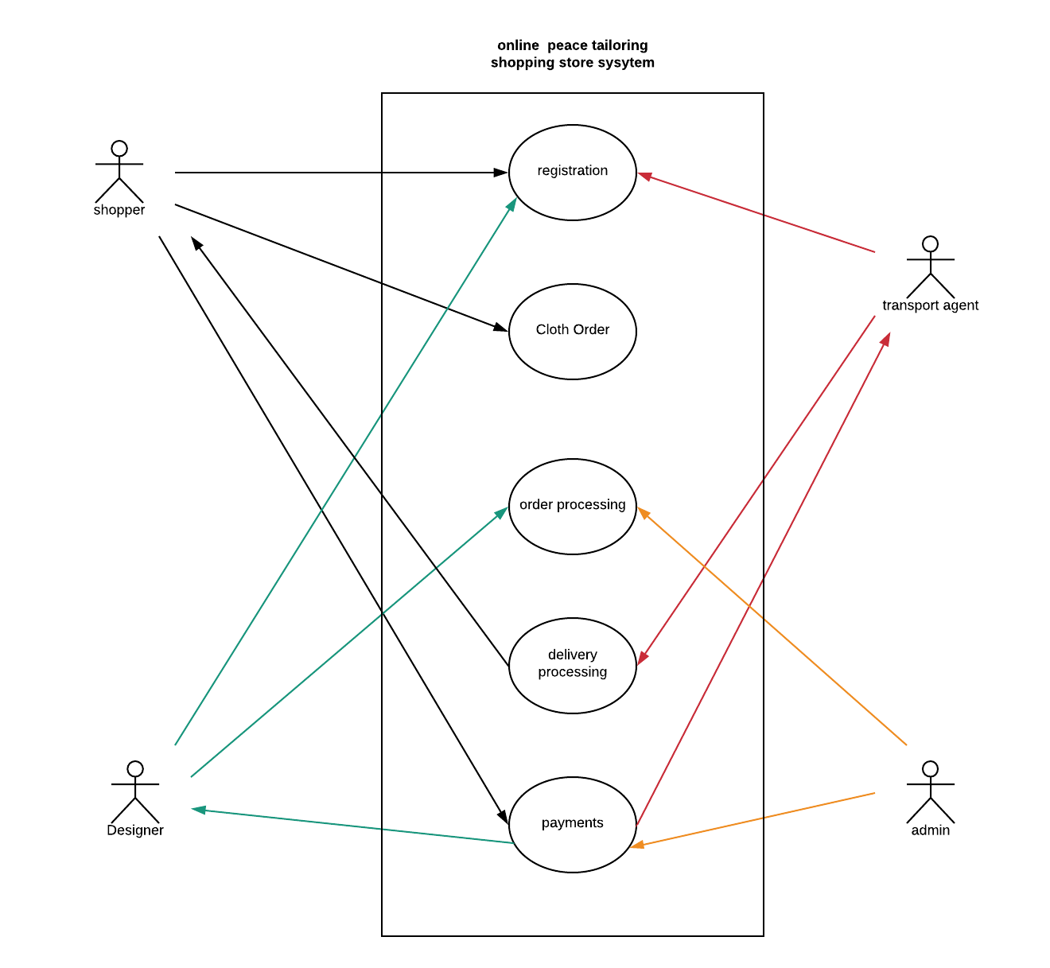

Figure 1Use Case diagram

The table below shows the Use Case diagram description with respective actors.

|  |  |  |
| --- | --- | --- |
| **Use Case** | **Actor** | **Description** |
| Registration | Shopper, designer and transport agent | This enables all the users to create account in the system and carry out their respective roles in the system. |
| Cloth order | Shopper | This allows the shopper to views the available clothing and therefore make an order based on his or her preferences. |
| Order processing | Designer, system admin | This enables the designers to accept the order from the shopper and produce a final product as per the shopper’s requirements. |
| Delivery processing | Transport agent | This allows the transport agent to receive the completed cloth orders and deliver them to the shopper’s premises. |
| Payments | System admin, Shopper, designer and transport agent | This allows both the designers and the transport agents to get payment once an order has been completed. It also allows the shoppers to get refunds on return of the purchases if they were not satisfied. |

Table 1 Use Case Table

## 4.2 Context diagram

This a diagram showing the main process that the system performs. The diagram gives the main entities of the system and the data flow into and out of the system. The rest of the component processes of the system are not displayed but hidden within the main process which is the process 0.

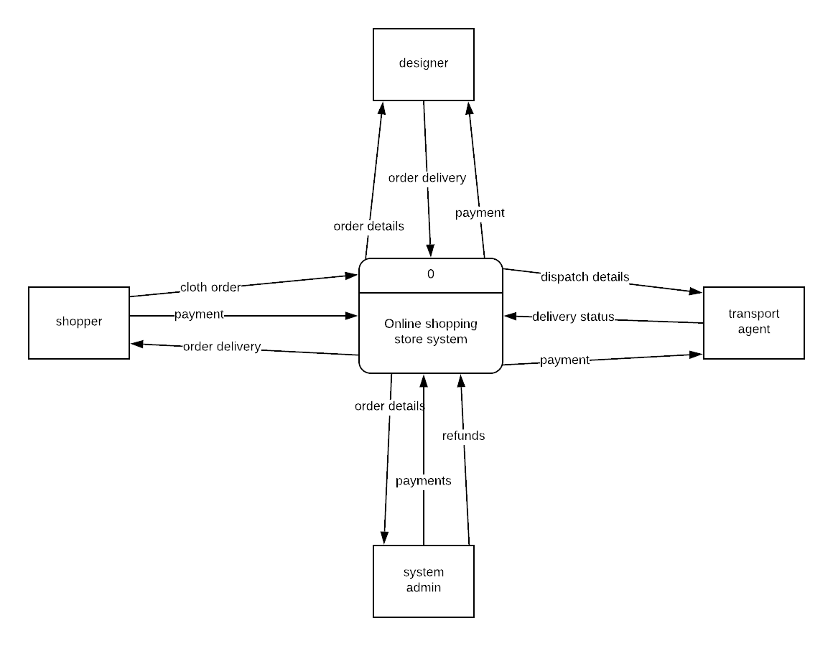

Figure 2Context Diagram

**4.3 Level 0 Data Flow Diagram: All system processes**

This is dataflow diagram that explodes all the major processes of the system associated with all the data flows and data stores in the system as the users of the system get to interact with the system.

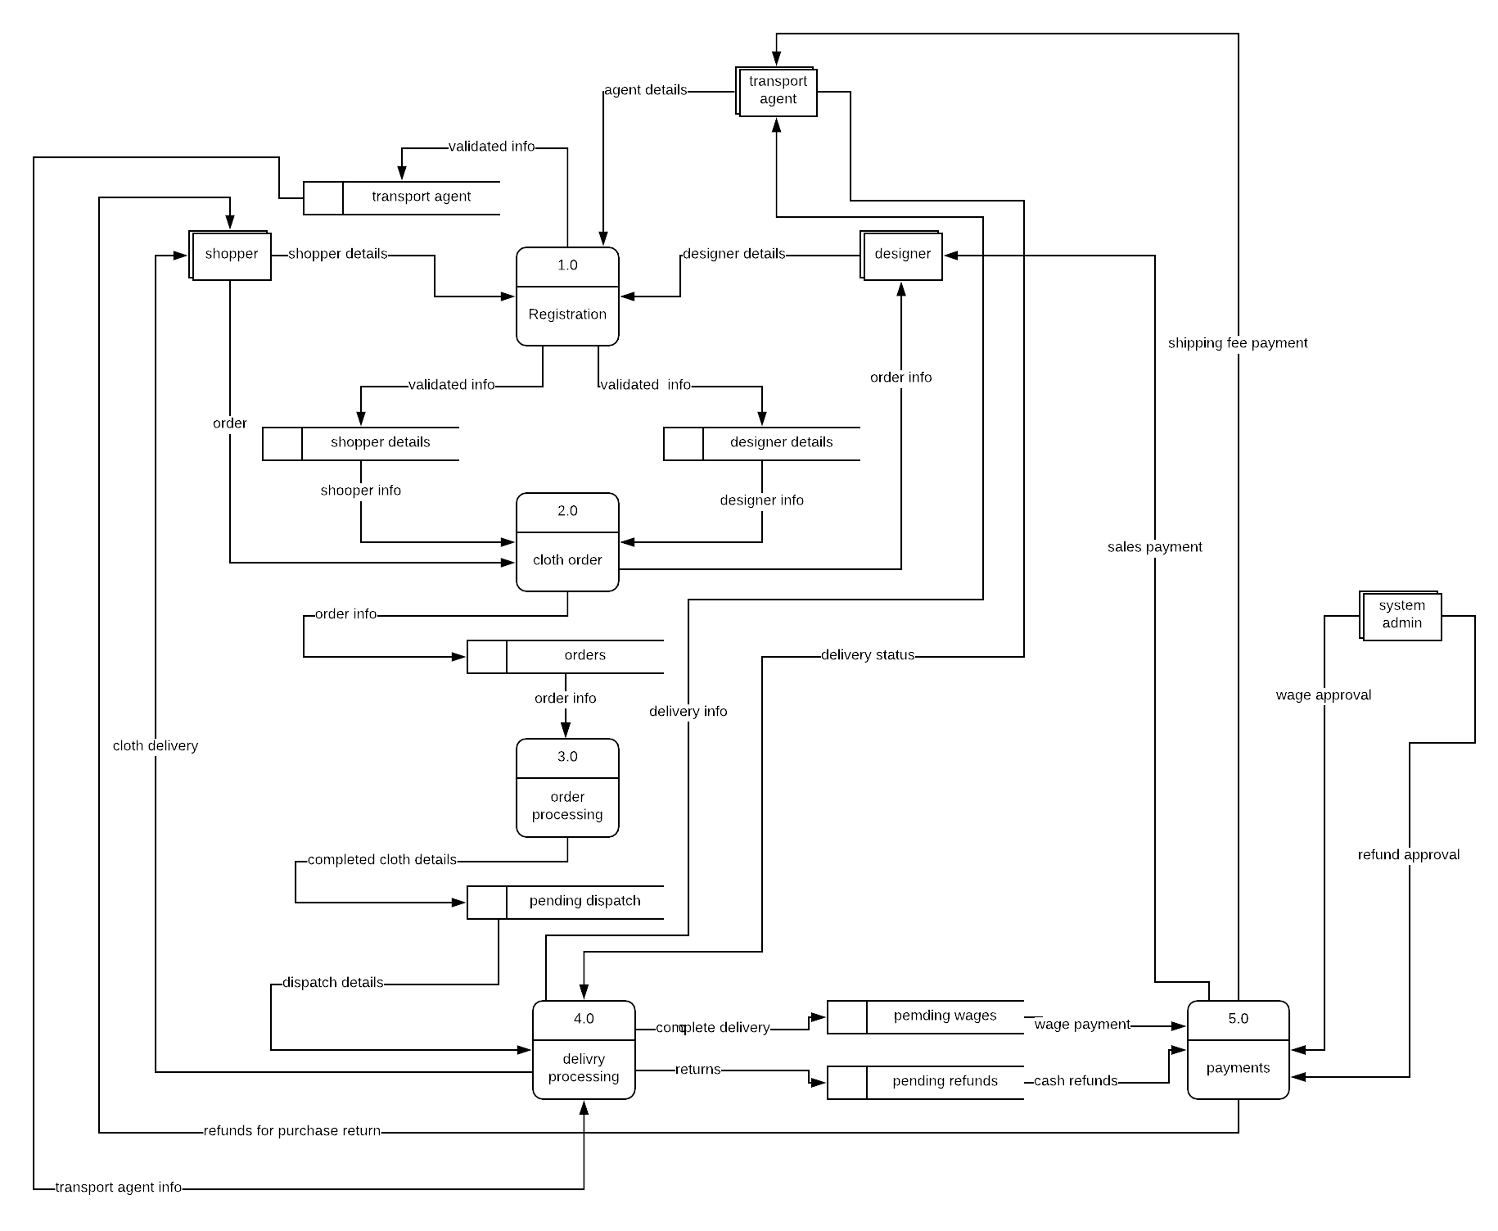

Figure 3 Level 0 DFD

## 4.4 Level 1 Data Flow Diagram: Payments

This is a diagram that explores one of the processes in the system as shown in the level 0 DFD at a more detailed manner. This just like the rest gives the entities involved, data flow, data stores and process after the breakdown of the of the process. This diagram explores the payment process from the level 0 data flow diagram.

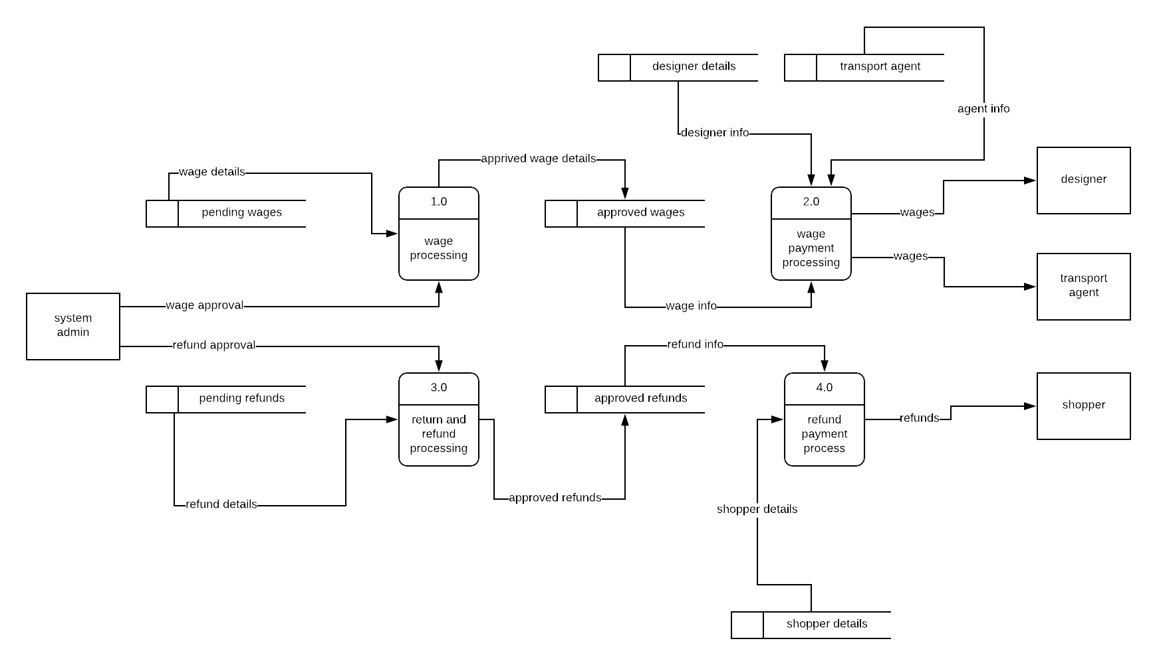

Figure 4 Level 1 DFD

# Chapter 5: Project plan and management

# 5.1 Project activity plan

|  |  |  |  |
| --- | --- | --- | --- |
| Item | Start date | End date | Hours |
| Requirement specification and analysis | 14/01/2019 | 21/01/2019 | 21hrs |
| Data modelling | 22/01/2019 | 29/01/2019 | 24hrs |
| System design | 30/01/2019 | 15/02/2019 | 51hrs |
| System implementation and prototyping | 16/02/2019 | 3/5/2019 | 231hrs |
| System testing and evaluation | 6/5/2019 | 18/5/2019 | 72hrs |
| System deployment | 20/5/2019 | 26/5/2019 | 18hrs |

## 5.2 Project Gantt Chart

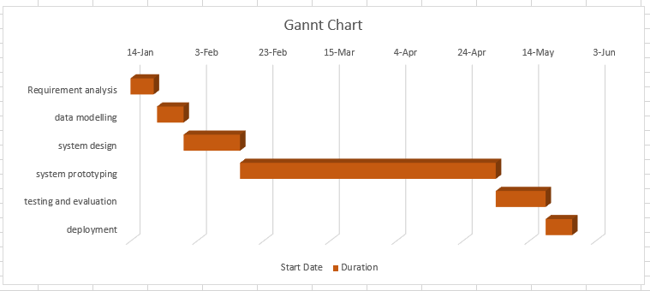

## 5.3 Required Resources

### 5.3.1 Software resources

The following software resources were required to complete the project

1. PHPStorm IDE
2. PyCharm IDE
3. Ubuntu Operating system
4. Google Chrome Browser

### 5.3.2 Hardware resources

The following software resources were required to complete the project

1. 4 Gigabytes of RAM.
2. 300Gigabytes of storage space.
3. 1 Gigabytes of dedicated graphics card memory.
4. 2Hz CPU processing speed.

# References

Anon., 2018. *How many Internet users are in Kenya?.* [Online]   
Available at: https://www.businessdailyafrica.com/corporate/tech/How-many-Internet-users-are-in-Kenya/4258474-4259072-htn83lz/index.html

Anon., 2018. *Jumia.* [Online]   
Available at: www.jumia.co.ke

Anon., 2018. *Mama Mike's online shop.* [Online]   
Available at: www.mamamike.co.ke

Anon., 2018. *Mimi Kenya.* [Online]   
Available at: 1.1.1 www.mimi.co.ke